

CHAROTAR UNIVERSITY OF SCIENCE AND TECHNOLOGY

FACULTY OF TECHNOLOGY AND ENGINEERING

B. TECH (IT/CE/CSE/AIML)

Practical : 11
Practical Statement:
- Write a Dockerfile for the React frontend and serve its production build from a small Nginx image using a multi-stage build.
- Write a Dockerfile for the Node/Express backend.
- Create a docker-compose.yml file that orchestrates frontend, backend, and MongoDB.
- Configure port mappings and an internal bridge network so containers can communicate.
- Configure the backend to connect to mongodb://mongodb:27017/taskdb and wait for MongoDB health before starting.
- Persist MongoDB data across container restarts with a named volume.
- Start the complete application with one Docker Compose command.
Screenshots of Output :
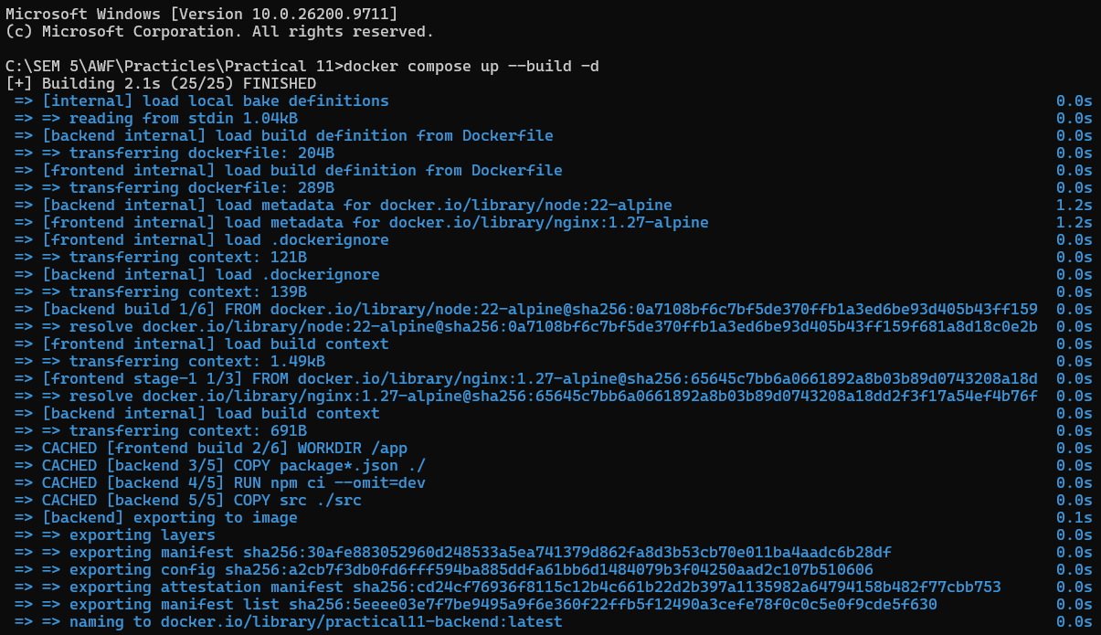
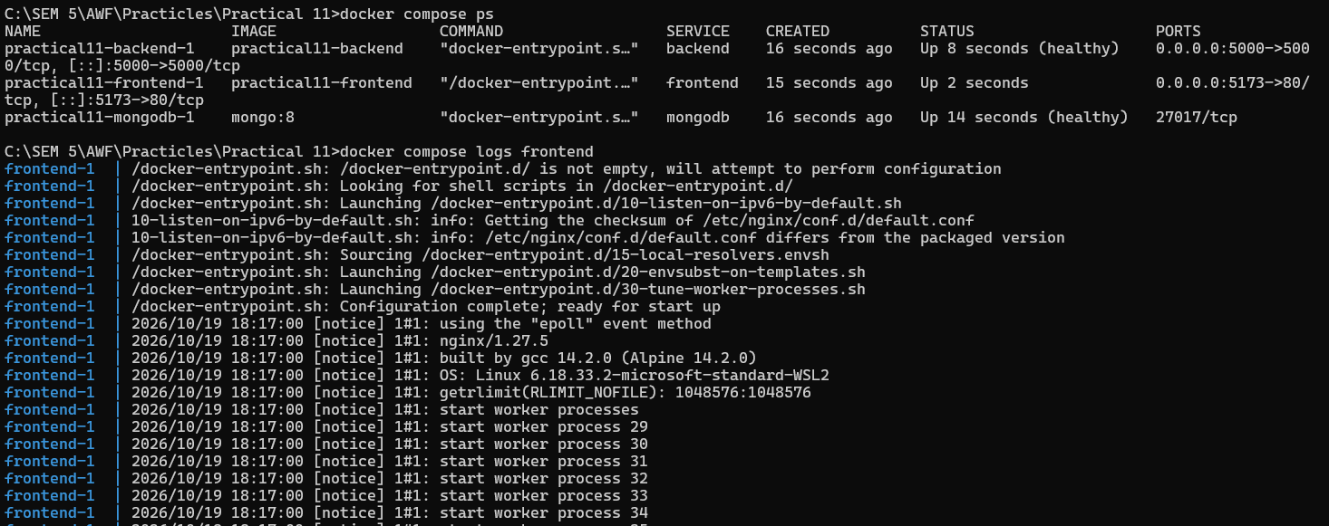
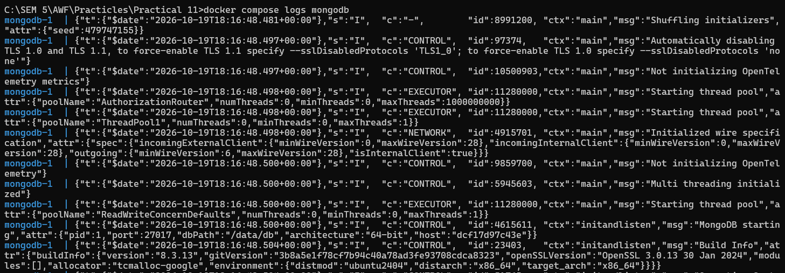
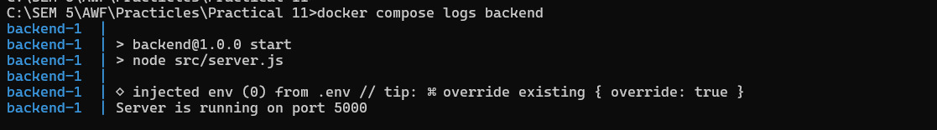

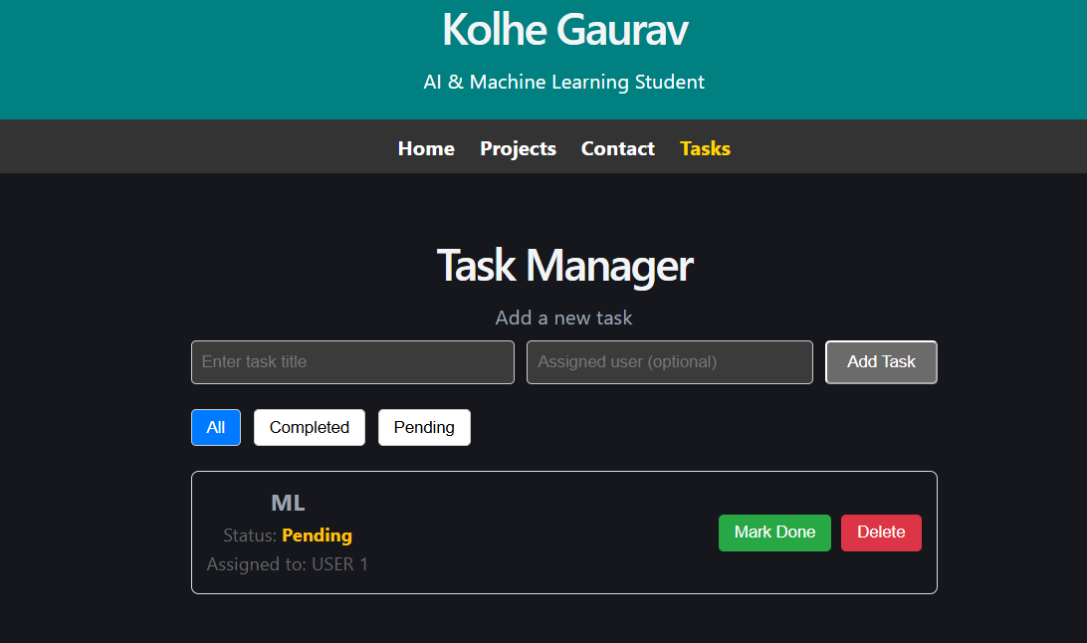
Added task
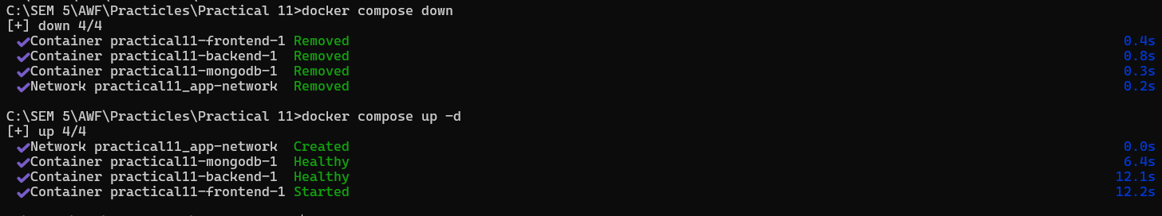
Key Questions / Analysis:
1. Why does the backend container need to reference MongoDB by its service name (mongodb) rather than localhost?
Answer: Each container has its own network namespace. Inside the backend container, localhost refers to the backend container itself, not the MongoDB container. Docker Compose provides DNS discovery on the shared app-network, so the mongodb service name resolves to the MongoDB container.
2. What is the difference between EXPOSE in a Dockerfile and a ports mapping in docker-compose.yml?
Answer: EXPOSE documents the port an application listens on inside its image; by itself, it does not publish that port to the host. A Compose ports mapping publishes and forwards a host port to a container port, making the service reachable from outside Docker.
3. Why is it bad practice to copy node_modules into a Docker image instead of installing dependencies inside the container?
Answer: Host node_modules may contain platform-specific binaries, unnecessary development packages, or dependencies that do not match the container operating system. Installing from the lockfile inside the image with npm ci is reproducible, avoids copying host artifacts, and keeps the build context and production image more controlled.
Key Skills Addressed:
- Writing Dockerfiles for frontend and backend Node.js applications.
- Orchestrating a multi-container app with Docker Compose.
- Configuring inter-container networking, service discovery, health checks, and port mappings.
- Building, running, and verifying a complete application stack with one command.
Learning Outcome:
Students will be able to containerize a full-stack application and orchestrate frontend, backend, and MongoDB using Docker Compose, running and verifying the stack with a single command.

Github Repo Link: https://github.com/Gauravk6531/Advanced-Web-Development-Frameworks/tree/Practical_6

